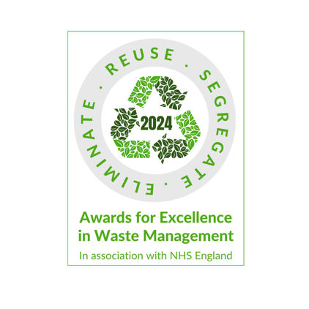

Awards for Excellence in Waste Management 2024

Terms & Conditions

- Winners must work within Waste Management teams working in secondary care within NHS England.
- Winners must be currently employed by NHS England.
- Winners may have worked within a healthcare over the past year, and still be employed within the NHS within a different role or department.
- Winners must be over 18 years of age.
- Winners will be chosen by the Waste Management judging panel.
- Competition entry is allowed and open between 15 April – 1 July 2024.
- Shortlists for each award will be announced in and around the 9 July 2024.
- Winners will be announced at a live ceremony on 2 October 2024.
- Winners will receive a physical award/trophy.
- Risk-pending (i.e., in the event of a national emergency), the Awards may come in either digital or physical form, the aim is to host a live awards ceremony in Birmingham 2 October 2024.
- If you are shortlisted for an award, you will be gifted a ticket to attend the Awards ceremony subject to availability.
- The winners will be asked to partake in a small-scale photo opportunity and may be asked to contribute and/or take part in other media activities and coverage of the awards.
- The details of the entry (including name and email address of nominee and nominator) may be shared internally within Ascent Events Ltd – the organisers for purposes relating to the competition - e.g., judging of competition, contact regarding submission, etc.
- One nominee per entry only, unless qualifying reasoning for multiples e.g., two people did the thing which you wish to nominate for, or you are nominating a team for the team awards.
- One entry per nominee is sufficient - multiple submissions for the same nominee aren't necessary. All additional nominations will be disallowed.
- Ascent Events are not liable for unclaimed prizes - prize winner has 3 months from close date of awards to claim their prize.
- In the event of any dispute concerning the correctness or acceptability of any award, the decision of the judges shall be final.
- If attending a live Waste Management Awards event, all images and videos from the event are the property of Ascent Events and may be used in the public domain in places such as (but not limited to) publications, digital publications, websites, social media & other forms of media - if you wish for your image not to be used, you must inform the company of this in writing at least 4 weeks before the Award ceremony takes place.
- There is no cost to enter the Waste Management Awards.
- No persons directly related to Ascent Events or the Waste Management judging panel may enter the awards.
- The reason for the nomination, including name of person nominating and nominee may be used in the public domain in places such as (but not limited to) publications, digital publications, websites, social media & other forms of media.
- All shortlisted entries will be vetted/check and their comms teams will be contacted - should this process highlight any wrongdoings of the individual; Ascent Events reserve the right to cancel the nomination. The shortlisted persons comms team will also have final say on the participation of the nominee.
- All awards submissions must come from within your organisation or related company to your organisation.

Last updated on 11 April 2024​

